|  |
| --- |
| C:\Users\mwagner\Desktop\millstone[2].jpg |

Dear Applicant,

Attached is an application for Smoke Detector, Carbon Monoxide Alarm and Fire Multiple Sources of Power Label Compliance. Please print or type the application and return with a check or money order for the appropriate fee made payable to the Board of Fire Commissioners.

The application fee for a certificate of Smoke Detector, Carbon Monoxide Alarm and Multiple Sources of Power Label compliance as required by N.J.A.C. 5:70-2.3, shall be based upon the amount of time remaining before the change of occupant is expected, as follows:

* Requests received more than Ten (10) business days prior to the change of occupant: $**45.00**;
* Requests received Four (4) to (10) Ten business days prior to the change of occupant: $**90.00**;
* Requests received fewer than Four (4) business days prior to the change of occupant: $**161.00**
* Required re-inspection due to non-compliance: $30.00 per Re-inspection

Effective September 1, 2013, the Bureau of Fire Prevention will no longer test monitored residential fire alarm systems. The homeowner or responsible party will be required to have the alarm company or a NJ Licensed Electrician certify the alarm is in good working order and provide documentation to the Bureau of Fire Prevention.

Governor Murphy signed into law P.L.2025, c.19 which, among other items, provides labeling requirements for certain residential structures containing secondary power sources. A structure used or intended for use for residential purposes by one or two households must have a label installed within 18 inches of the main electrical panel and electrical meter warning of the dangers associated with secondary power sources. A secondary power source may include permanently installed internal combustion generators, solar panels, battery storage systems, or any other supplemental source of electrical energy to the primary power supply. The label must be marked with the wording similar to “CAUTION: MULTIPLE SOURCES OF POWER.” and may not be handwritten. A label compliant with ANSI Z535.4 will meet the requirements of this law and may be referenced in the subsequent regulations.

Effective March 1, 2025 fire extinguishers will no longer be required for change of occupancy in 1 & 2 family dwellings.

Should you have any questions please call the Bureau of Fire Prevention at (609) 259-2560.

Thank you,

Matthew Wagner

Matthew Wagner

Fire Official

**Smoke Alarms**

ONE & TWO-FAMILY DWELLINGS

**\*Smoke Alarms that are 10 years of age or older shall be replaced prior to the inspection. Smoke Alarms that are found to be 10 years of age or older during the inspection will result in failure of the inspection. \***

Built Prior to 1977:

* Battery operated smoke alarm installed on each floor/level (including basement), within 10 feet of bedrooms.
* Ten-year sealed battery-powered single station smoke alarms shall be installed and shall be listed in accordance with ANSI/UL 217, incorporated herein by reference. However, A/C-powered single or multiple-station smoke alarms installed as part of the original construction or rehabilitation project shall not be replaced with battery-powered smoke alarms. The effective date of this subsection shall be January 1, 2019.

Built After 1977:

* Hardwire Electric Interconnected smoke alarm installed on each floor/level (including basement), within 10 feet of bedroom.

Built After 1990:

* Hardwire Electric Interconnected smoke alarm with battery back-up installed on each floor/level (including basement), within 10 feet of bedroom.
* Hardwire Electric Interconnected smoke alarm with battery back-up installed in each bedroom.

Built After 2008:

* 110v Hardwire Electric Interconnected smoke alarm with battery back-up installed on each floor/level (including basement), within 10 feet of bedroom.
* 110v Electric Interconnected smoke alarm with battery back-up installed in each bedroom.

Note: If you had a combination burglar/fire alarm system installed in the past and you only find (1) one smoke detector connected to the alarm system – Even though the detector may be operating correctly, approval or certification ***will not***be issued on such a system, as it is a non-approved system. ***At no time, were single detectors only approved in New Jersey.***Smoke Detectors must conform to the above criteria to gain certification.

**Typical Placement of Smoke Alarms**

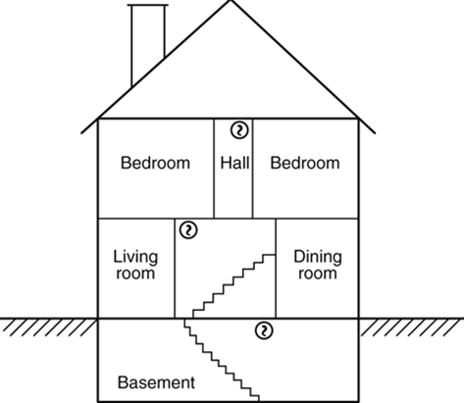 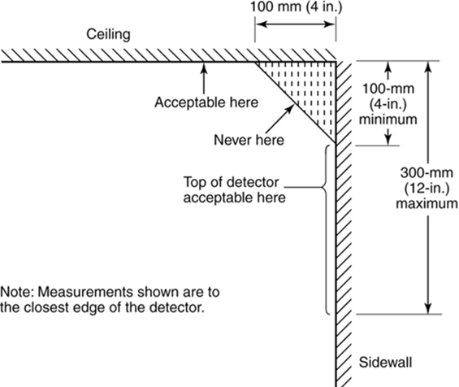

**Carbon Monoxide Alarms:**

UL 2034 and NFPA 720

The CO alarm is required to be manufactured, listed, and labeled in accordance with UL 2034 entitled, “Single- and Multiple – Station Carbon Monoxide Alarms.” Each device shall have a label indicating that it meets this requirement.

In the locations specified above, the alarms are required to be installed as follows:

* The device is permitted to be a battery powered, hard wired or plug-in type.
* If installing an electrically operated device, the AC power source is required to be supplied from either a dedicated branch circuit or the un-switched portion of a branch circuit used for power and lighting. Operation of a switch (other than a circuit breaker) or a ground-fault circuit interrupter is not permitted to cause loss of power to the alarm.
* The alarm may be located on the wall, ceiling, or other location as specified in the manufacturer’s instructions.
* The device is required to be supported independently of its attachment to wires.
* For alarm installed in the vicinity of sleeping rooms, the alarm notification appliance is required to be clearly audible in all bedrooms over background noise levels and with all intervening doors closed, with a minimum rating of 85dBA at 10 feet (3m). If the alarm is intended to notify occupants of the same room, the sound pressure level is permitted to be 75dBA at 10 feet.

Under most situations, compliance with the requirements listed above should be acceptable for approval of the installation. However, should a situation arise that is not addressed above, please refer to NFPA 720 for additional installation requirements. For your information, Kidde Safety has recalled some CO devices. The models that have been recalled are the “Nighthawk” and the “Lifesaver”. The Nighthawk models included in this recall are all models manufactured between November 8, 1998 and March 9, 1999. The date of manufacture is on the back of the unit as year, month, and day. “Nighthawk” and “Carbon Monoxide Alarm” are written on the front of the unit. If only “Carbon Monoxide Alarm” is written on the front, the unit is NOT included in the recall. The “Lifesaver” models included in the recall are models 9CO-1 and 9CO-1C manufactured between June 1, 1997 and January 31, 1998. The manufacture date is on the back of the unit as the first six numbers of the serial number, located above the UPC. The manufacture date is written as day, month, and year. “Lifesaver” and “Carbon Monoxide Detector” are written on the front of the unit. Should you identify a unit that has been included in the recall, do not approve its installation; direct the owner to contact Kidde Safety at (888)543-3346.

**Application for a Certificate of Smoke Alarm, Carbon** **Monoxide Alarm,**

**And**

**Fire Multiple Sources of Power Label Compliance**

Property Owner: __________________________________________________

Property Address: Street __________________________________________

Millstone Township, State N.J. Zip: __________

Block#__________ Lot#__________

Home Phone (___) ____-______ Cell Phone (___) ____-______

Applicant/Agent: __________________________ Contact # (___) ____-______

• Requests received more than Ten (10) business days prior to the change of occupant: $**45.00**;

• Requests received Four (4) to (10) Ten business days prior to the change of occupant: $**90.00**;

• Requests received fewer than Four (4) business days prior to the change of occupant: $**161.00**

• Required re-inspection due to non-compliance: $30.00 per Re-inspection

Each inspection shall be conducted by a representative of the Bureau of Fire Prevention. The detectors required shall be located in accordance with NFPA 74-84 for smoke alarms and NFPA 720 for carbon monoxide alarms. The alarms are not required to be interconnected. Battery powered detectors are acceptable. Note: Smoke alarms in homes constructed after January, 1977 provided with AC powered and / or interconnected alarms shall be maintained in working order. See diagrams for further information regarding installation attached to this application.

__________________________________________________________________________________________

**FOR OFFICIAL USE ONLY**

Date Received: ____/____/____ Received By: _______________ Paid: Check # _________

Inspection Date: ____/____/____ Inspection Time: ________ Fee $ ______

**Re-inspection**

Date Received: ____/____/____ Received By: _______________

Fee $ ______ Paid: Check # _________